**Experiment 2.3**

**K-Nearest Neighbors**

**Student Name: SANSKAR AGRAWAL UID:20BCS5914**

**Branch: CSE Section/Group:20BCS_MM_806-B**

**Semester: 5th**

**Subject Name: Machine Learning Lab Subject Code: CSP-317**

1. **Aim/Overview of the practical:**

Apply KNN classifier on iris dataset**.**

1. **Source Code:**

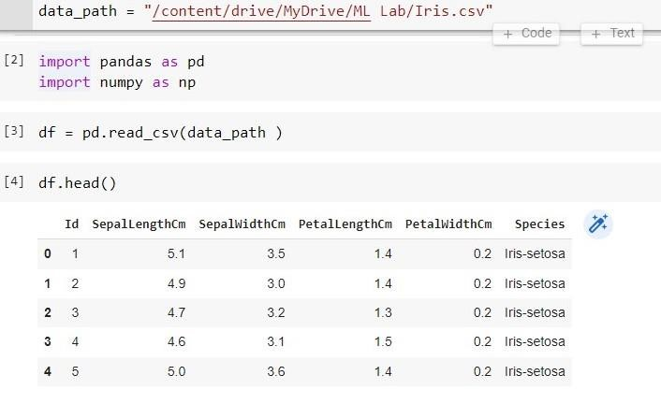

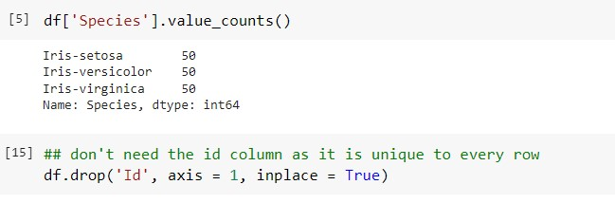

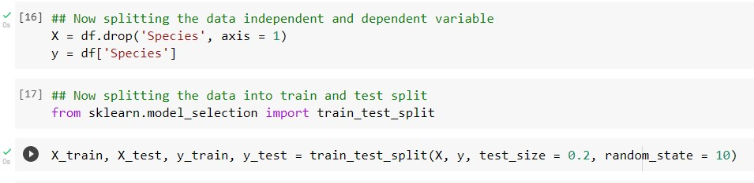

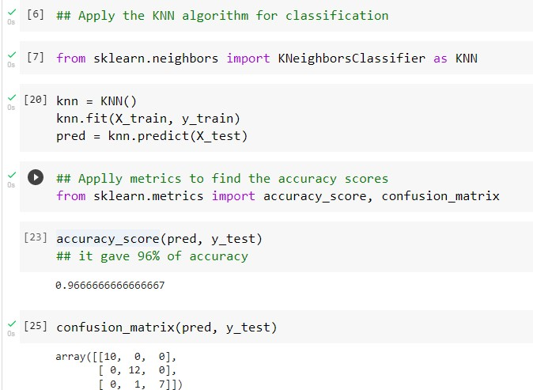

**Learning outcomes (What I have learnt):**

* 1. Learn about the KNN algorithm
  2. Learn to perform the KNN algorithm on iris dataset
  3. Learnt about the exploratory data analysis
  4. Learn to optimize the Model
  5. Got the clear concept of KNN classifier **Evaluation Grid :**

|  |  |  |  |
| --- | --- | --- | --- |
| **Sr. No.** | **Parameters** | **Marks Obtained** | **Maximum Marks** |
| **1.** | **Student Performance (Conduct of experiment) objectives/Outcomes.** |  | **12** |
| **2.** | **Viva Voce** |  | **10** |
| **3.** | **Submission of Work Sheet (Record)** |  | **8** |
|  | **Total** |  | **30** |